

**BOOK LIBRARY**

**Software Requirement Specification**

– Hanoi, january 2023 –

Record of changeS

|  |  |  |  |
| --- | --- | --- | --- |
| Date | A* M, D | In charge | Change Description |
|  |  |  |  |
| 31/Jan | A | TrangVT | Thêm mô tả chức năng Login (II.1.a) |
|  | A | HuyNQ | Thêm mô tả chức năng quản lí Profile (customer) |
|  | A | VuVT | Thêm mô tả chức năng Dashboard |
|  | A |  | Thêm mô tả chức năng quản lí Product |
|  | A |  | Thêm mô tả chức năng quản lí Order |
|  | A | TrangVT | Thêm mô tả chức năng trang chủ |
|  |  |  |  |
|  |  |  |  |
|  |  |  |  |
|  |  |  |  |
| 13/Apr | A | KienNT | Thêm mô tả chức năng Setting Details (II.1.a) mẫu |

*A - Added M - Modified D - Deleted

**Table of Contents**

I. Overview 4

1. Introduction 4

2. System Functions 5

3. Entity Relationship Diagram 6

II. Functional Requirements 7

1. Login 7

a. <<Function Name 1>> 7

b. <<Function Name 2>> 7

2. <<Feature Name 2>> 7

# I. Overview

## 1. Introduction

*[Content part 1: presents a high-level overview of the product and the environment in which it will be used, the users, and known constraints, assumptions, and dependencies]*

*[Content part 2: describes the product's context in the form of a context diagram in which you present the boundary and connections between the system you’re developing and everything else in the universe. This identifies external entities (or terminators – software, hardware, human components, and other systems) outside the system that interface to it in some way, as well as data, control, and material flows between the terminators and the system]*

<<Sample: The Cafeteria Ordering System is a new software system that replaces the current manual and telephone processes for ordering and picking up meals in the Process Impact cafeteria. The system is expected to evolve over several releases, ultimately connecting to the Internet ordering services for several local restaurants and to credit and debit card authorization services.

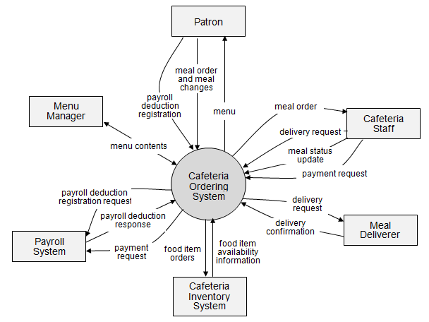>>

## 2. System Functions

#### a. Screen Flow

*[This part shows the system screens and the relationship among screens. You can draw the Screens Flow for the system in the form of diagram as below]*

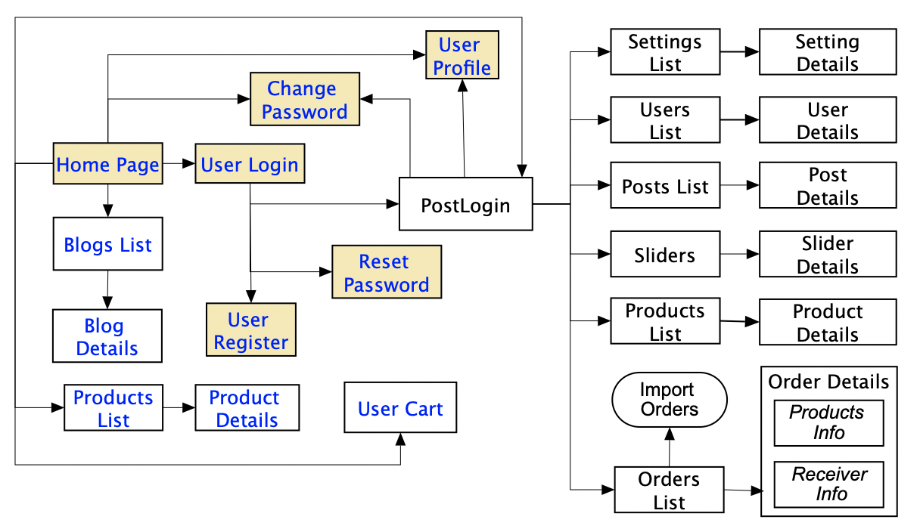

#### b. Screen Details

*[Provide the descriptions for the screens in the Screens Flow above]*

|  |  |  |  |
| --- | --- | --- | --- |
| **#** | **Feature** | **Screen** | **Description** |
| 1 | Order Meals | Create Order | <<Screen Brief description>> |
| 2 | Order Meals | Change Order |  |
| 3 | .. |  |  |

#### c. User Authorization

*[Provide the system roles authorization to the system features (down to screens, and event to the screen activities if applicable) in the table form as below – replace Role1, Role2,… with the specific system user role names]*

|  |  |  |  |  |  |
| --- | --- | --- | --- | --- | --- |
| **Screen** | **Role1** | **Role2** | **Role3** | **Role4** | **RoleX** |
| <<Screen Name1>> | X |  |  | X | X |
| <<Screen Activity>> |  |  |  | X | X |
| <<Screen Name2>> | X |  |  | X |  |
| Query All Data | X |  |  |  |  |
| Query Own Data |  |  |  | X |  |
| Query Managed Data |  |  |  | X |  |
| Add New Data |  |  |  | X | X |
| Update All Data |  |  |  |  | X |
| Update Own Data |  |  |  |  | X |
| Update Managed Data |  |  |  |  | X |
| Delete Data |  |  |  |  |  |
| … |  |  |  |  |  |

In which:

* Role1: <<role1 description>>
* Role2: <<role2 description>>
* …

#### d. Non-Screen Functions

*[Provide the descriptions for the non-screen system functions, i.e batch/cron job, service, API, etc.]*

|  |  |  |  |
| --- | --- | --- | --- |
| **#** | **Feature** | **System Function** | **Description** |
| 1 | <<Feature Name>> | <<Function Name1>> | <<Function Name1 Description>> |
| 2 | … |  |  |

## 3. Entity Relationship Diagram

*[Provide the entity relationship diagram and the entity descriptions in the table format as below]*



**Entities Description**

|  |  |  |
| --- | --- | --- |
| **#** | **Entity** | **Description** |
| 1 | User |  |
| 2 | Meal |  |
| 3 | Meal Subscription |  |
| 4 | … |  |

# II. Functional Requirements

## 1. <<Feature Name 1>>

### a. <<Function Name 1>>

*[A function can be a screen or a non-screen function (listed in the part I.2.d above). In this part, you need to provide the details on the related function, focus on mentioning below information*

* *Function trigger: how this function is triggered (navigation path, a timing frequency, etc.)*
* *Function description: actors/roles, purpose, interface, data processing, etc.*
* *Screen layout: mockup prototype of the screen, sample below is for Manage Products screen*

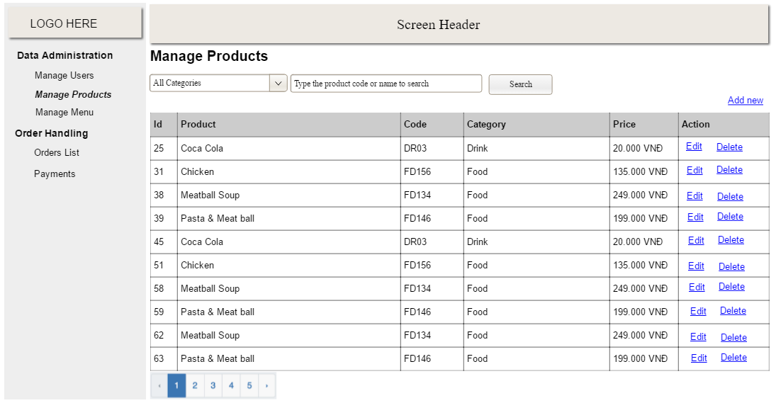

* *Function Details: provide explanation for the data, validation, business logics, functionalities (for both normal cases and abnormal cases), etc. of the function so that the reader can image how it work.*

*]*

### b. <<Function Name 2>>

…

## 2. <<Feature Name 2>>

…